Report on Data Recovery
Student’s Name
Institutional Affiliations

Report on Data Recovery
Introduction
To begin with, data recovery is a process of restoring information that has been lost, accidentally deleted, made inaccessible, or even corrupted. Typically, data recovery refers to the restoration of information to a laptop, server, external storage system, or a desktop from a backup. With that said, many Windows and third-party tools are utilized to recover lost data. This report addresses various steps that can be used in recovering lost data utilizing different windows and third-party tools. Some of the windows and third-party tools used in recovering data include EaseUS file recovery software, portable data recovery, TestDisk, Recuva, Restoration, as well as wise data recovery.
Windows Tools and Third-Party Tools that Can be used for Data Recovery
EaseUS file recovery software is a well-recognized windows tool that is widely utilized in armies, courts, governments, as well as other high confidential places in a country to recover lost information. In particular, the tool has powerful data recovery capacity and can recover high profile data such as decrypted as well as compressed information and file or even recover substantial information from a damaged hard drive, memory card, disc, or other available media storages. The aforementioned software uses three steps to recover lost data. The first step involves connecting a device such as an SD card or USB to the PC. In case one lost important data on an external hard drive, SD card, or even USB, he or she needs to connect it to the PC. The second step is running the data recovery software as well as scan lost information. In this case, one should run EaseUS data recovery wizard on the PC and then select the device where the data was lost under hard disk drives, external devices, or specify a location. Afterwards, he or she should click on scan to begin scanning the lost information. Step three needs the individual to preview and restore data. After scanning, one is required to double click each file to preview them from the following tabs. Delete files tab includes all deleted files. Drive tab consists of loads and lost partition files that require one to check first if the hard drive is formatted or partition is deleted. Additionally, the extra file tab consists of all files that lost names or paths on the drive. Lastly, one can choose that lost information as well as specify a safe location on the PC to complete the data recovery process by clicking recover now tab.
TestDisk is a third-party recovery tool that plays a vital role in recovering lost partitions as well as makes bootable noon-bootable drives. Nevertheless, the success of this tool relies on the extent the partitions are damaged. The tool at hand takes part in fixing a partition table, recover or rebuild NTFS, undelete and copy files from NTFS, ext3, ext2, and FAT file systems, as well as recover a deleted partition. The tool in question possesses features for experts and invoices. For the individuals who understand little or even nothing about data recovery techniques, they can utilize TestDisk to collect extensive information concerning a non-booting drive that can then be sent to a tech for further analysis. On the other hand, those individuals familiar with such procedures should find TestDisk a handy tool in performing onsite recovery. It is important to note that TestDisk can run under DOS, Windows, Linux, FreeBSD, NetBSD, OpenBSD, SunOS, as well as MacOS X.
Portable data recovery is considered one of the Pendrive Apps that is used to recover data from NTFS, FAT, FAT32, and FAT16 partitions. Specifically, this app recovers some compressed as well as encrypted files and it consists of a wipe tool that enables an individual to delete a file to protect deleted sensitive data. The firm should recover to a drive other than the one the information is recovered from (Wallen, 2012). The aforementioned software is capable to recover from all removable media devices including Thumb Drive, Jet Flash Drive, USB Drive, as well as Handy Drive, to mention a few. It is important to understand that Pendrive data recovery software works to retrieve lost information from corrupted or even damaged memory stick data storage media. Notably, the tool can restore as well as retrieval lost, deleted, and missing music, videos, images, text files, digital photos, and even pictures from inaccessible mass storage disks or even other storage media. With that said, the Pendrive recovery software has three steps to follow. First, one must run Pendrive discovery software where the drive is connected to the PC. In the main interface, select the Pendrive under external devices and then click scan to begin the Pendrive recovery process. Step two involves scanning the Pendrive where the program is let to scan as well as determine all lost files. Step three is to recover Pendrive files where an individual is required to check three tabs including delete files, lost partition files, or extra files to determine the lost files and the software allows one to double-click to preview them. Finally, one is required to click recover to save them to secure location on the PC or another external storage device.
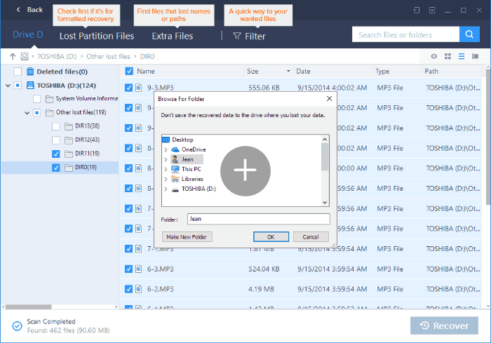
Figure 1: Pen drive recovery software
Recuva takes part in offering tons of features for a portable app. The tool helps a firm or an individual to undelete files, restore unsaved word documents, recover deleted iPod music, as well as recover information from a damaged disk. Furthermore, this tool has an easy-to-use quick start wizard, can delete files, and can carry out deep scans. As a matter of fact, Recuva plays a vital role in recovering lost files from disks that might have become corrupt or even damaged through software or physically. It is noteworthy that the process is like running Recuva, but one must tell the tool to scan for non-deleted files. To set this tool to recover lost files from damaged or even formatted disks, one must start Recuva by entering an advanced mode in case the wizard launches. Then click options, then click on the actions tab. After that, click scan for non-deleted files and then OK. At this point, run the Recuva scan as normal and at this point, non-deleted files are indicated with a green double-circle status icon.
In addition, wise data recovery enables an organization to recover word documents, video, emails, audios, photos, and archives, to mention a few. On the same note, the tool at hand indicates the condition of the file to recover and an individual gets immediate feedback after a scan showing whether a file is lost, poor, or good. Lastly, restoration enables an individual to restore files that were deleted from a recycle bin or deleted from Windows (Wallen, 2012). The tool allows an individual to scan upon app startup, limit search outcomes with search strings, as well as securely wipes files beyond simple recovery. Notably, restoration works with FAT, SD cards, and NTFS. The users must be cautious when running the aforementioned app because it offers to install third-party software. One must pay attention when running the executable.

Data Recovery Steps Summary
- Selecting the recovery module
- Selecting the source disk or partition for data recovery
- Performing the scan for files
- Selecting search files to be recovered
- Selecting the file storage location for saving searched files (Robinson, 2015)
- Saving the selected recovered files

References
Wallen, J. (2012). Five free portable recovery tools. The Republic. Retrieved from https://www.techrepublic.com/blog/five-apps/five-free-portable-recovery-tools/
Robinson, P. (2015). Data recovery- step by step. Ontrack. Retrieved from https://www.ontrack.com/uk/blog/concepts-explained/data-recovery-step-by-step/

